**Interview prospective programming questions**

# 1. Write a program to find factorial of the given number. ?

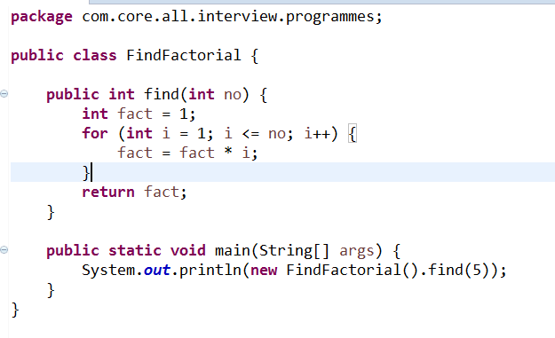2. Write a program to check whether the given number is even or odd.

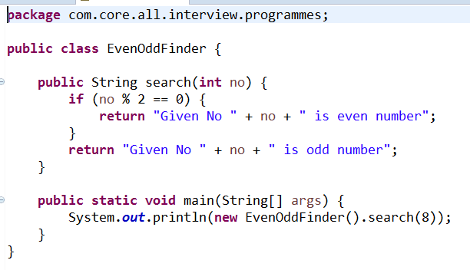

3. Write a program to swap two numbers using a temporary variable.

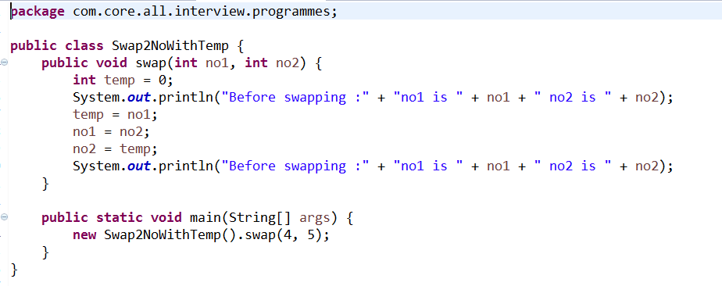4. Write a program to swap two numbers without using a temporary variable.

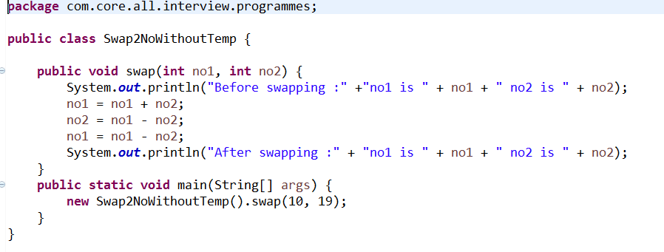

5. Write a program to swap two numbers using bitwise operators.

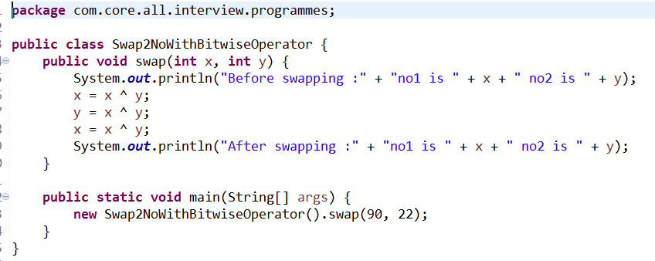

6. Write a program to find the greatest of three numbers.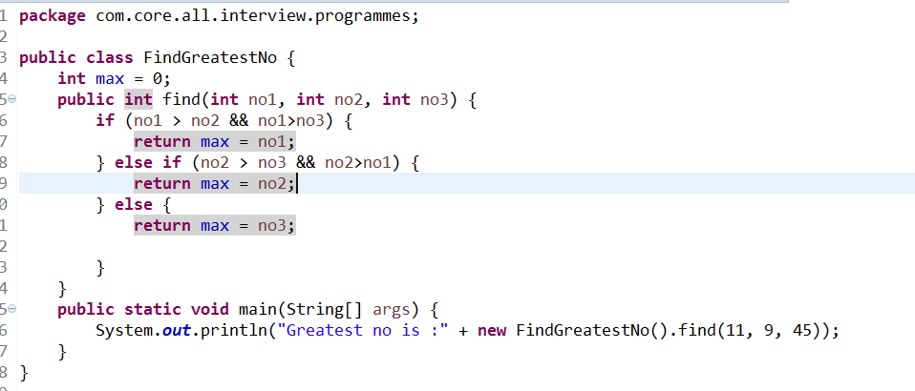7. Write a program to find the greatest among ten numbers.  
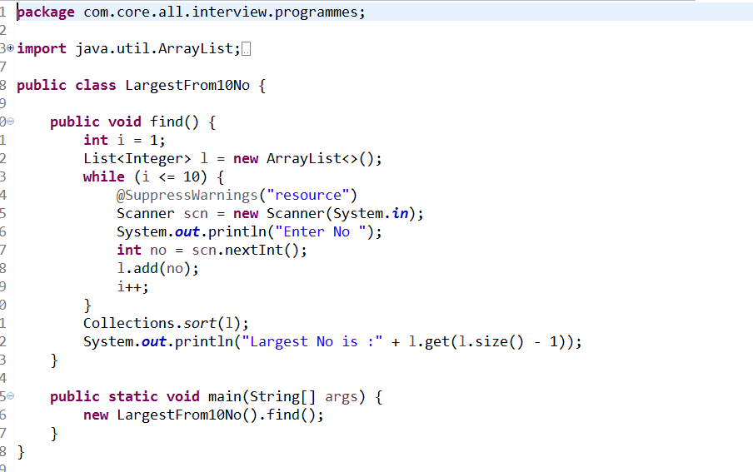

# 8. Write a program to check whether the given number is a prime.

# 9. Write a program to check whether the given number is a palindrome c number.

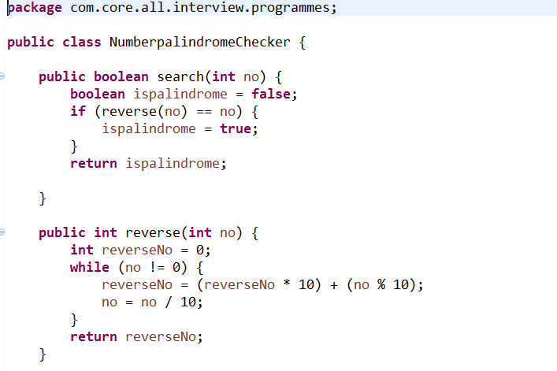

10. Write a program to check whether the given string is a palindrome.

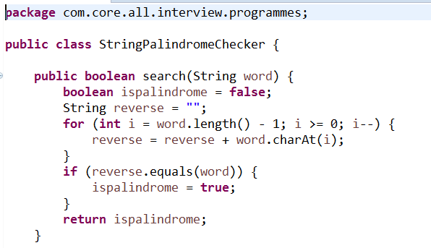

# 11. Write a program to generate the Fibonacci series.

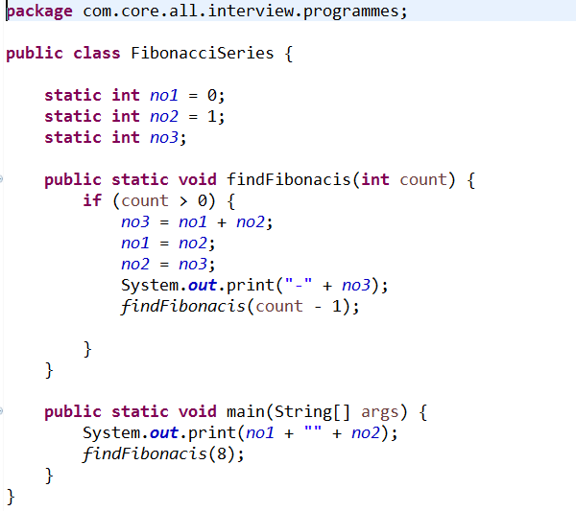

# 12. Write a program to print "Hello World" without using semicolon anywhere in the code.

# 

# 13. Write a program to print a semicolon without using a semicolon anywhere in the code.

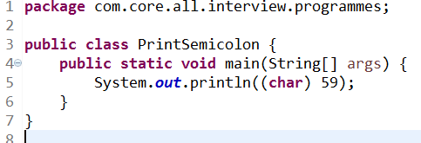

# 14. Write a program to delete a specified line from a text file.

# 

# 15. Write a program to find the number of lines in a text file.

# 16. Write a program to display the multiplication table of a given number.

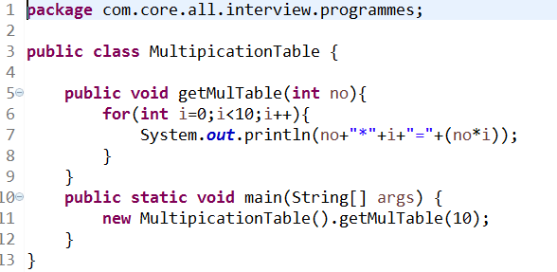

# 17. WAP to find out the longest word in a string.

# 18. WAP to print the triangle of letters in increasing order of lines..

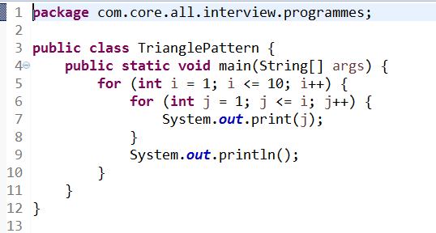

# 19. WAP to print 'xay' In place of every 'a 'in a string

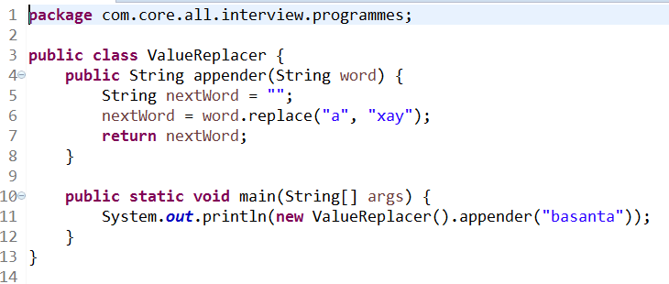

# 20. Count the Total Number of 7 coming between 1 to 100.

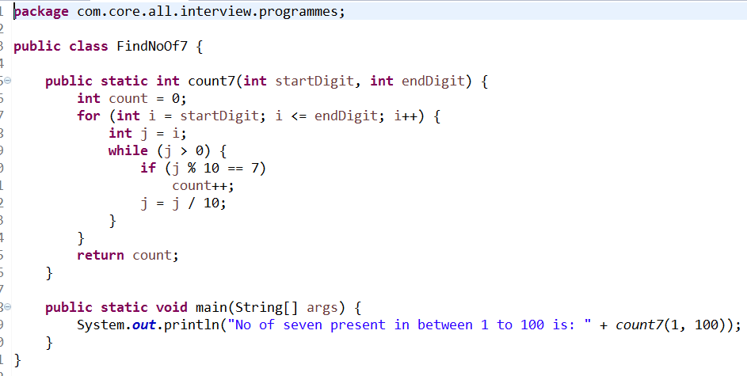

# 21. WAP to find out if a given number is a power series of 2 or not?

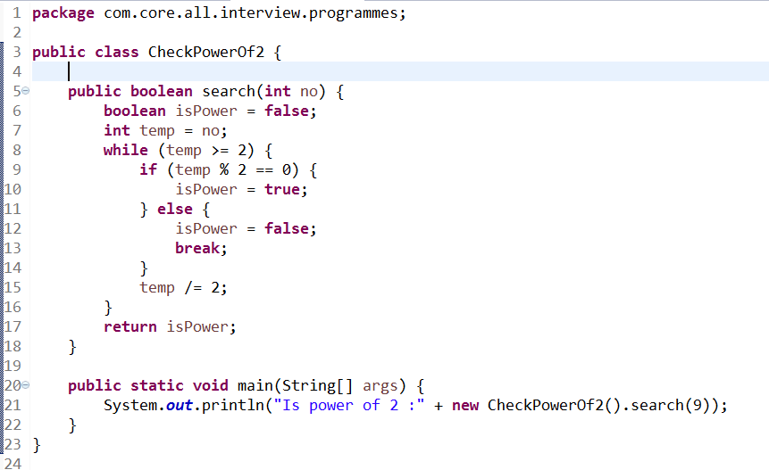

# 22. WAP to check Array Equality without using predefined method.

**package** com.array.prog;

**import** java.util.Arrays;

**public** **class** ArrayEquality {

// Approach : 1(By using Predefined methods)

**public** **boolean** equal(**int**[] i1, **int**[] i2) {

**boolean** isEqual = **false**;

Arrays.*sort*(i1);

Arrays.*sort*(i2);

**if** (Arrays.*equals*(i1, i2)) {

isEqual = **true**;

} **else** {

isEqual = **false**;

}

**return** isEqual;

}

// Approach : 2(without using Predefined methods)

**public** **boolean** equalArray(**int**[] i1, **int**[] i2) {

**boolean** isEqual = **false**;

**for** (**int** i = 0; i <= i1.length - 1; i++) {

**for** (**int** j = 0; j <= i2.length - 1; j++) {

**if** (i1[i] == i2[j]) {

isEqual = **true**;

}

}

}

**return** isEqual;

}

**public** **static** **void** main(String[] args) {

System.***out***.println("is Equal :"

+ **new** ArrayEquality().equal(**new** **int**[] { 1, 2, 3, 4 },

**new** **int**[] { 4, 3, 2, 1 }));

System.***out***.println("is Equal :"

+ **new** ArrayEquality().equalArray(**new** **int**[] { 1, 2, 3, 4 },

**new** **int**[] { 1, 2, 3, 4 }));

}

}

# 23. WAP to find duplicate from Array?

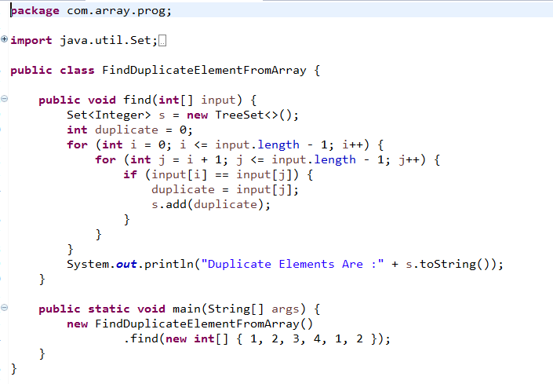

# 24. WAP to print second largest number of given Array?

# 

# 25. WAP to find sum of no forgiven number from Array?

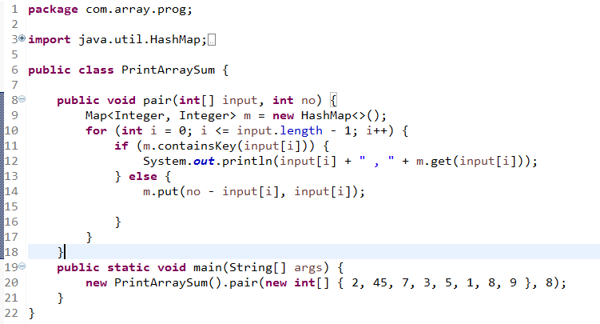

# 26. WAP to find duplicate from String?

***By using Collection:***

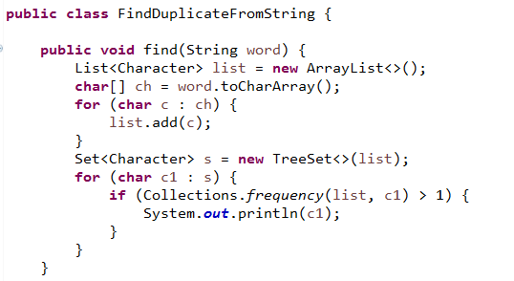

***By using String method:***

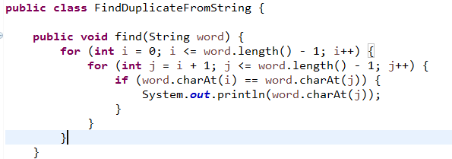

# *27.* WAP to find number of occurrence of character from given String?

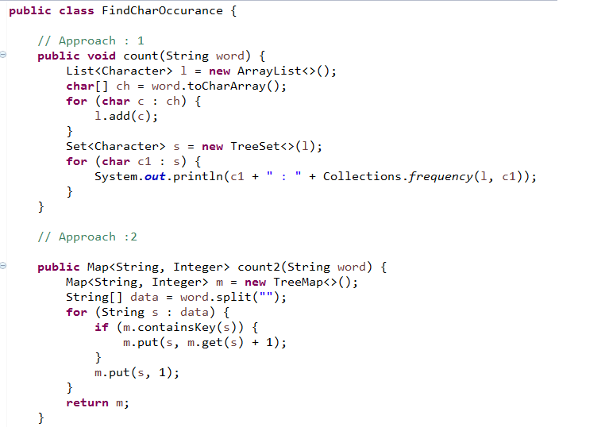

# 28. WAP to remove White Space from given Sentence?

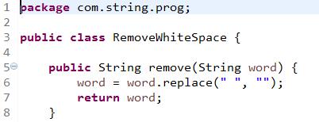

# 29. WAP to check string anagram?

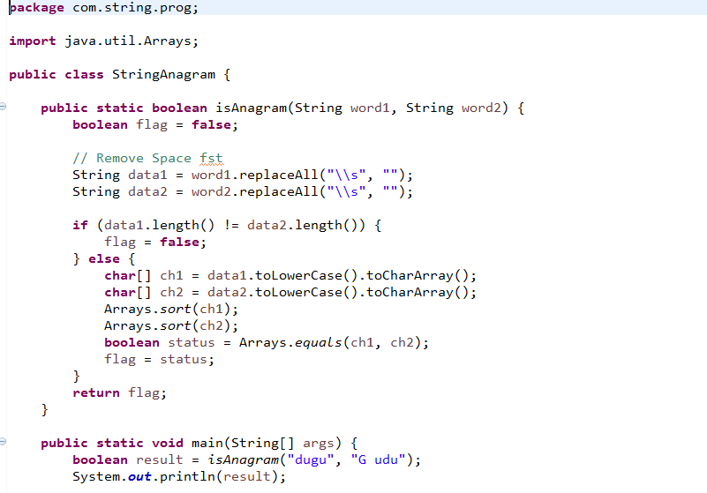

# 30. WAP to reverse string?

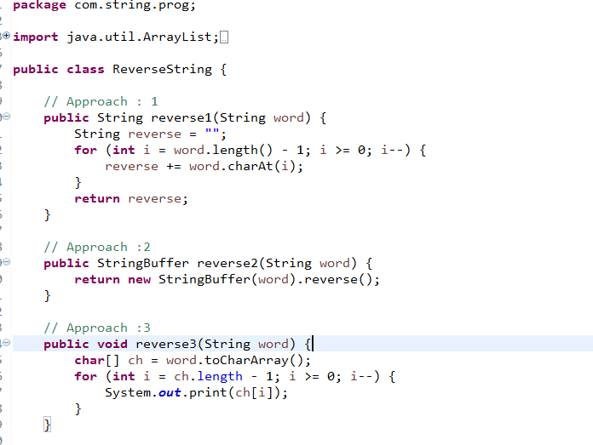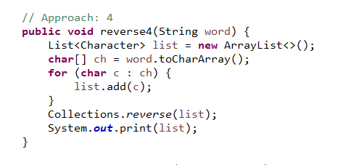

# 31. WAP to find Armstrong number?

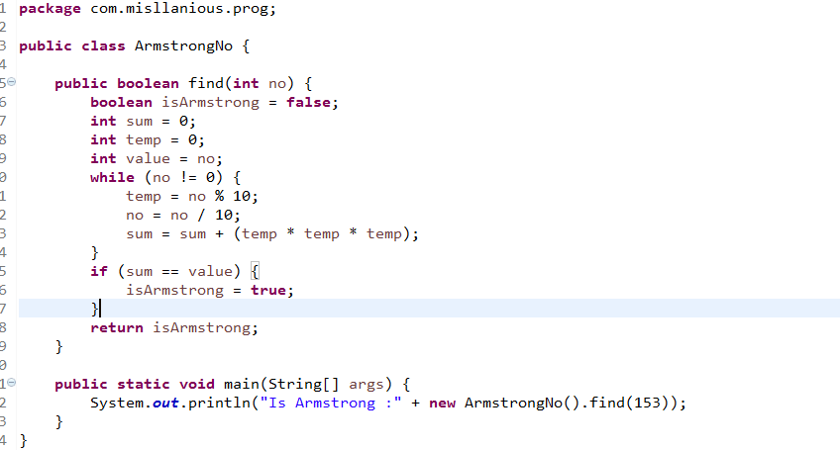

# 32. WAP to find sum of digit?

